**DHCP Spoofing Attack**

**A DHCP spoofing attack occurs when an attacker sets up a rogue DHCP server within a network. This rogue server sends fraudulent DHCP responses to clients, tricking them into accepting incorrect IP configurations. The attacker can then redirect traffic through malicious gateways or DNS servers, enabling them to intercept data, launch man-in-the-middle attacks, or cause denial of service. The main objective is to manipulate network traffic for malicious purposes, compromising the network's security and integrity.**

**LAB on DHCP Spoofing Attack**

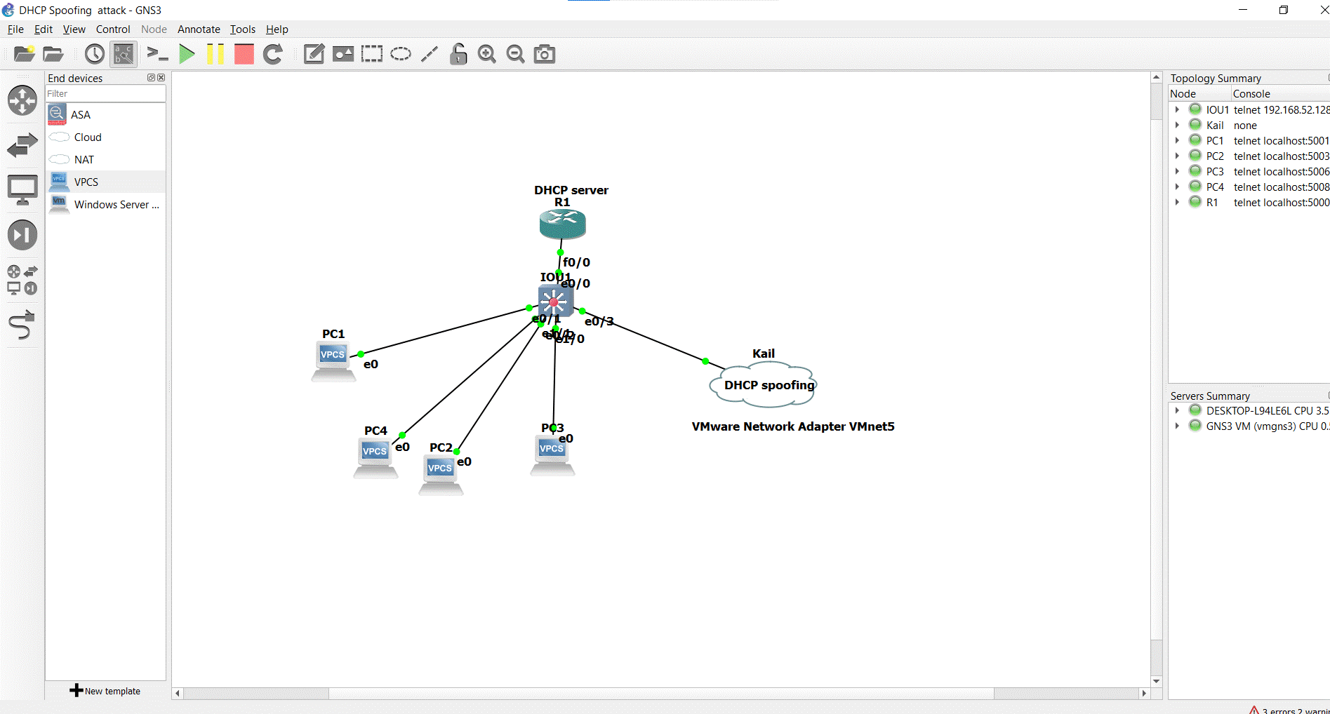

**Step for configurations**

1. **Enter on Router and enable DHCP**

**R1(config)#int f0/0**

**R1(config-if)#ip address 10.0.0.1 255.0.0.0**

**R1(config-if)#no shutdown**

**R1(config-if)#exit**

**R1(config)#ip dhcp pool DHCP**

**R1(dhcp-config)#network 10.0.0.0 255.0.0.0**

**R1(dhcp-config)#default-router 10.0.0.1**

**R1(dhcp-config)#dns-server 8.8.8.8**

1. **Enter on All PC**

**PC> dhcp**

1. **Launch DHCP Attack**

**Enter on Kail**

**#**

1. **Enter all PC for check ip**

**Secure of DHCP Spoofing**

**Enter on Switch**

**IOU1(config)#ip dhcp snooping vlan 1**

**IOU1(config)#ip dhcp snooping**

**IOU1(config)#no ip dhcp snooping information option**

**IOU1(config)#interface e0/0**

**IOU1(config-if)#no shutdown**

**IOU1(config-if)#ip dhcp snooping trust**

**IOU1(config)#interface e0/3**

**IOU1(config-if)#no shutdown**

**IOU1(config-if)#ip dhcp snooping limit rate 3**